Resolution #3

Resolution Regarding Prevention and Response
to Crisis with Rostered Church Professionals and/or Their Families

WHEREAS, Protestant clergy have been found to have higher levels of occupational stress compared to leaders of other faiths; and

WHEREAS, according to a study of clergy health conducted by the United Methodist (UM) church the prevalence of chronic health conditions has increased among clergy. Depression was prevalent among a subgroup of North Carolina UM clergy, with 9% reporting depressive symptoms in the past two weeks (higher that the 6% national average). Clergy ranked the need for access to mental health counseling among their top 3 desired health programs; and

WHEREAS, none of the existing mission teams of the Delaware-Maryland Synod has the specific focus of care for the stress and crisis of rostered professionals and/or their families or the ability to make this a priority given their current work load;

WHEREAS, this synod has experienced several and severe episodes of crisis among its rostered professionals – including suicide;

WHEREAS, current processes and resources may not be sufficient to deal with every pending or current crisis among our rostered professionals and/or their families;

WHEREAS, many congregations do not fully understand the stress and pressure endured by our rostered professionals and/or their families or have a mechanism in place to support their rostered professionals;

THEREFORE, BE IT RESOLVED, that the Synod Council of the Delaware-Maryland Synod, ELCA, shall establish a separate Ongoing Task Force for the sole purpose of advocacy and management of resources and services to prevent and/or respond to crisis situations among the rostered professionals and/or their families in this synod. The Synod Council will determine the size and make up of the task force; with intention given to broad representation from across the synod, lay and rostered leaders with experience in counseling, social work, or other related fields, and diversity in regards to race, gender, and roster; and

BE IT FURTHER RESOLVED, that the Ongoing Task Force will consider new positions of “Synod Chaplain for Crisis Intervention” on the territory of the synod. The primary purpose will be to triage and connect each person with resources and services. Chaplains would be expected to periodically attend gatherings of rostered professionals to seek in all ways to build trust and rapport with the rostered professionals. Synod Chaplains would maintain confidentiality. Synod Chaplains would be asked to serve pro bono; and

BE IT FURTHER RESOLVED, that, the Ongoing Task Force will partner with synod staff to create a referral network and list of counselors, coaches, and spiritual directors as soon as possible; and

BE IT FINALLY RESOLVED, that, the Ongoing Task Force shall create a program of educational opportunities for the congregations of our synod. Educational opportunities will include equipping congregations to better understand the pressures of being a rostered church leader and empowering them to better support and care for rostered leaders and their families.

Submitted by: (writing team written in bold)

Rev. Michael Adams, Christ, Trenton
Rev. David Baker, Washington County Hospital, Hagerstown
Rev. Anke Deibler, Calvary, Mt. Airy
Rev. Eric Deibler, Calvary, Mt. Airy
Rev. Katrina Holland, St. Paul, Jefferson
Rev. Chad Kline, Abiding Savior, Columbia
Rev. Kristi Kunkel, New Light, Dundalk
Rev. Fred Lehr, Interim Minister
Rev. Stacy Marsh, Retired
Dr. Jane Pearson, Calvary, Mt. Airy
Rev. Kathryn Rohrbach, Interim Minister
Mrs. Regina Schneider, Calvary, Mt. Airy
Rev. Jimmie Schwartz, Carroll Lutheran Village, Westminster
(additional signatures below)

Reference and Counsel recommends: Adoption

Rationale:

+ This builds on the resolution adopted by the 2012 synod assembly resolution;

+ Provides a means and method for immediate crisis intervention in the lives of
rostered leaders and their families in the sense of triage, short-term crisis
care as may be needed.
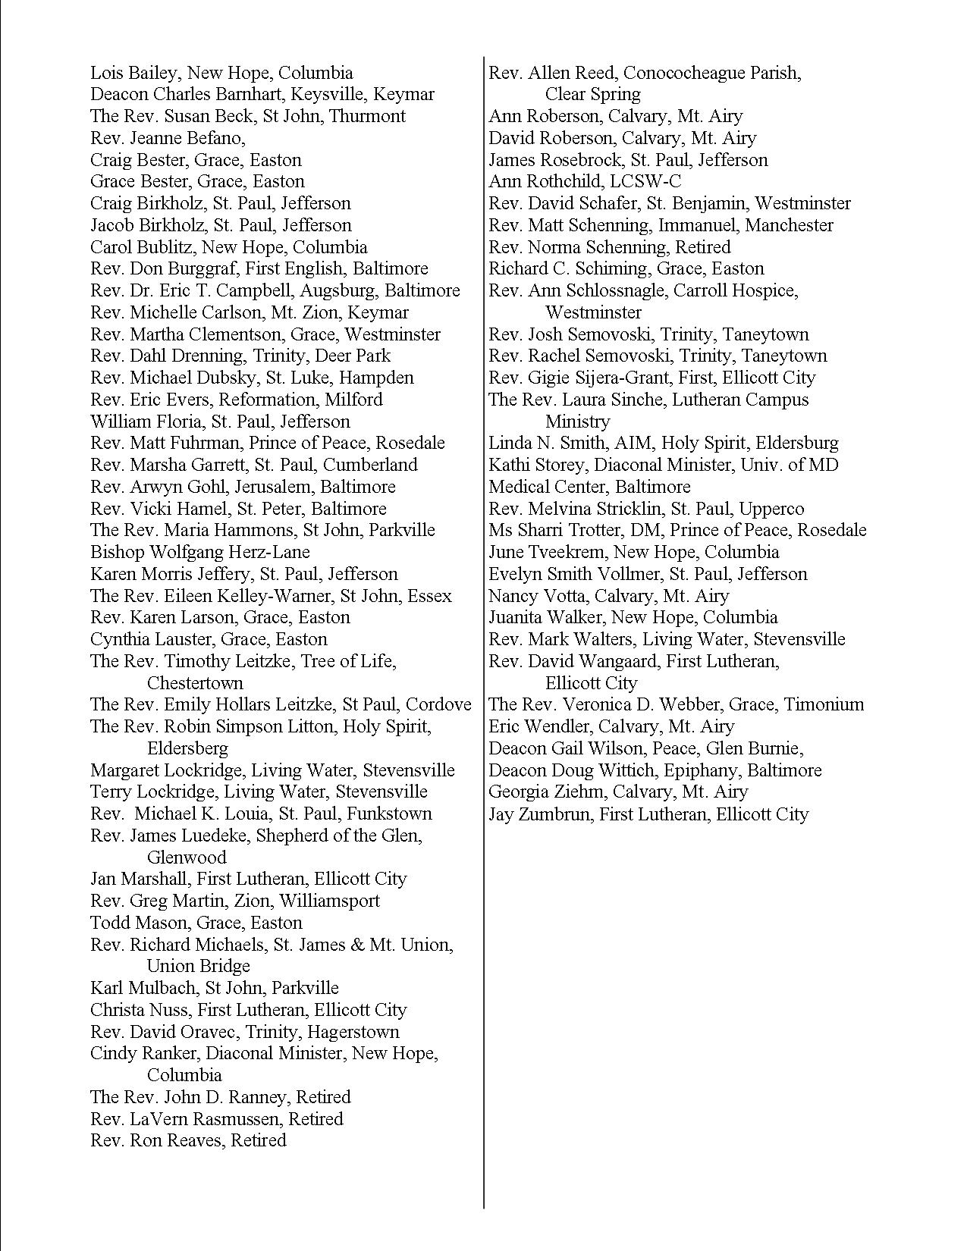

A.J. Weaver, K.J. Flannelly , D.B. Larson, C. Stapleton, & H.G. Koenig, “Mental Health Issues Among Clergy and Other Religious Professionals: A review of research.” The Journal of Pastoral Care & Counseling, Winter 2002, Vol. 56. Nov. 4. 393-402.
General Board of Pension and Health Benefits and the General Board of Higher Education and Ministry of The United Methodist Church, Church Systems Task Force Report, May 2011, Accessible at: http://www.gbophb.org/TheWell/Root/CFH/4225.pdf r
R.J. Proeschold-Bell, S. LeGrand , A. Wallace, J. James, H.E. Moore, R. Swift & D. Toole, “Tailoring Health Programming to Clergy: Findings From a Study of United Methodist Clergy in North Carolina,” Journal of Prevention & Intervention in the Community, 2012,40:3, 246-261

